

LODE-BD Recommendations 1.0
Report on how to produce Linked Open Data (LOD)-enabled bibliographical data

Prepared by:
Imma Subirats
FAO of the United Nations, Office of Knowledge Exchange, Research and Extension
Marcia Lei Zeng
Kent State University, School of Library and Information Science

This work is funded in part through the EC Project VOA3R (project number)

Abstract

The LODE-BD Recommendations address the questions of how to encode existing bibliographic data hosted by various open repositories for the purpose of exchange across data providers and how to produce Linked Open Data (LOD)-enabled bibliographic data. The initial goal is to present a tool that will assist the data providers in selecting appropriate encoding strategies according to their needs in order to facilitate metadata exchange through the VOA3R (Virtual Open Access in Agriculture and Aquaculture Repository) platform. The core component of the LODE-BD report contains a set of recommended decision-making trees for common properties used in describing a bibliographic resource instance (article, monograph, thesis, conference paper, research report, etc. – in print or electronic format). Each decision tree is delivered with various acting points and the matching encoding suggestions, usually with multiple options. In spite that the recommendations are geared to the agriculture and aquaculture sectors through the VOA3R project, the report is destined to become useful for any type of bibliographical data describing bibliographic resources in any subject domain.
Status of the Document
This is a draft document and may be updated or replaced by a new version at any time. The report will be published in May 2011 and subsequently revised according to suggestions starting from the end of the year. The recommendations will be published and maintained by the Agricultural Information Management Standards (AIMS) of the Food and Agriculture Organization (FAO) of the United Nations.

Comments on this document may be sent to Imma Subirats <Imma.Subirats@fao.org>, please include the text "LODE-BD comment" in the subject line.

Table of Contents
1. About the Report 4
1.1 Background 4
1.2 Key Principles 4
1.3 Disclaimer 5
2. Scope and Methodologies 6
2.1 Scope 6
2.2 The Concept Model 6
2.3 Groups of Common Properties 8
2.4 Metadata Standards Used in the LODE-BD Recommendations 10
2.5 Explanation of Terminology 11
2.6 Crosswalk of Metadata Terms 12
2.7 The Flowcharts 14
3. The Recommendations 16
1. Title 17
[2. Responsible Body] 19
2.1 Creator 19
2.2 Contributor 22
2.3 Publisher 24
[3. Physical Characteristics] 26
3.1 Date 26
3.2 Identifier 28
3.3 Language 30
3.4 Format 32
3.5 Edition/Version 34
3.6 Source 36
4. Location 38
5. Subject 40
[6. Description of Content] 43
6.1 Description/Abstract 43
6.2 Type/Form/Genre 45
7. Intellectual property. Rights 47
8. Usage 49
[9. Relation] 51
9.1 Relation between resources 51
9.2 Relation between agents 53
Appendixes 55
Appendix A. Explanation of Terminology 55
Appendix B. References 57
How to publish and consume Linked Data 57
Where to find Linked Data sets 57
Syntax guidelines 58

1. About the Report

The report, entitled LODE-BD Recommendations, addresses the questions of how to encode existing bibliographic data hosted by various open repositories and communities for the purpose of exchange across data providers and how to produce Linked Open Data (LOD)-enabled bibliographic data. The initial goal of the LODE-BD Recommendations is to present a tool that will assist data providers in selecting appropriate encoding strategies according to their needs in order to facilitate metadata exchange of the agriculture and aquaculture sectors through the VOA3R platform. The report is destined to become useful for any type of bibliographical data describing a bibliographic resource (article, monograph, thesis, conference paper, research report, etc. – in print or electronic format) in any subject domain.

1.1 Background
The idea of assisting information professionals to decide what metadata terms to use when encoding existing bibliographic data for the purpose of exchange and sharing across data providers was born under the umbrella of VOA3R. VOA3R has the goal to develop a platform for exchanging bibliographic data to improve the dissemination of research results in agriculture and aquaculture via open access. In order to reach this goal, VOA3R data providers need to deal with the initial issues such as what data needs to be exchanged and how. Some simple example questions could be: “Will be the physical holding of a resource important enough to be shared among the VOA3R participants?” “What metadata term should be used for encoding the title(s), identifier(s), or location of a resource?” Furthermore, as data providers continue to gravitate towards the direction of Linked Open Data, they will likely have additional questions. For example, controlled vocabularies such as AGROVOC and LCSH, both having been used in their databases for a long time, are now available as Linked Data. So, what kind of data value for ‘subject’ property should be exchanged: the original string (literal) or the URI of a concept (non-literal)? And what metadata term should be used for a non-literal value, dc:subject, or dcterms:subject?

The LODE-BD report thus is prepared with dual objectives: the first is to meet the needs of a platform for exchanging bibliographic data via open access, without the requirements of considering Linked Data. The second is to provide recommendations for advancing such exchange to the Linked Open Data-enabled level. The report introduces a set of recommended decision-making trees for common properties that are used in describing a bibliographic resource. It is the long-term plan of the authors that, after receiving feedback from the participating data providers in VOA3R and external advisors, the recommendations will be revised to incorporate various situations and needs as well as the emerging technologies in the Linked Data movement.

1.2 Key Principles
Recognizing the facts that bibliographic data providers usually have different bibliographic data structures and may be situated at different stages in considering Linked Data, LODE-BD provides multiple sets of action points and the matching encoding suggestions for each of the properties.

There are five key principles of the LODE-BD Recommendations:

- Facilitating the decision-making process regarding data encoding for the purpose of exchange and reuse;
- Encouraging the use of authority data, controlled vocabularies, and syntax encoding standards whenever possible in order to enhance the quality of the interoperability and effectiveness of information exchange;
- Promoting the use of well-established metadata standards as well as the emerging LOD-enabled vocabularies proposed in the Linked Open Data Community;
- Encouraging the use of resource URIs as data values in metadata when they are available;
- Providing a tool that is open for suggestions of new properties and metadata terms according to the needs of the LOD community as well as the needs of data providers.

1.3 Disclaimer
These recommendations do not intend to include cataloguing description rules or how to publish linked data. The current recommendations are only applicable for bibliographic data of bibliographic resources, although in the future the recommendations can be extended to accommodate other kinds of information resources.

2. Scope and Methodologies

2.1 Scope
Best practices of metadata can be gathered from different perspectives based on the emphasized processes. Metadata-related standards have been created by different communities for specifics purposes - to guide the design, creation, and implementation of data structure, data values, data content, and data exchange in an efficient and consistent manner. Using a simple illustration, metadata standards can be categorized into these groups in accordance with their primary purposes and functions.
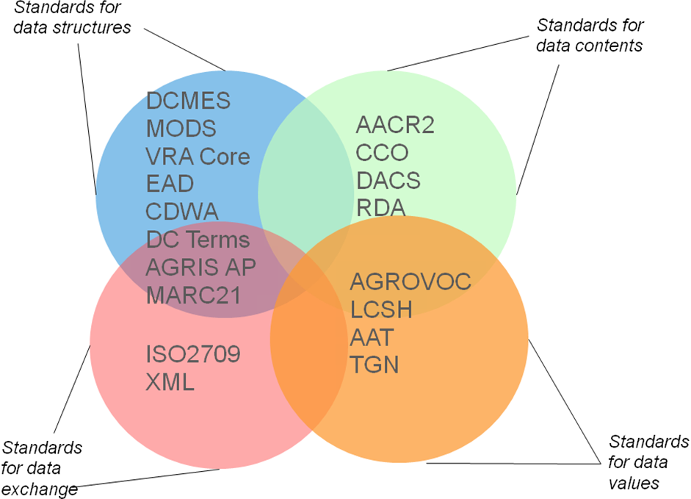
Figure 1. An illustration of different types of metadata standards
according to their primary purposes and functions
The LODE-BD recommendations only focus on the implementation of standards for data structures (e.g., on which namespace and what properties would best fit for an encoding decision), combined with limited consideration for data contents (e.g., on what metadata properties are mandatory and which value space should consider using controlled vocabulary).

2.2 The Concept Model
The LODE-BD Recommendations has taken both bottom-up and top-down approaches. The selection of the properties to include in this report is from bottom-up. The properties are supported by the literary warrant and user warrant as evidenced by the data models in operation. The top-down approach is to use a conceptual model for sharing the common understanding of the important entities and relationships for bibliographic data. The conceptual model is built on a FRBR-based model previously developed by the AIMS of the FAO, with enormous extension and reconsideration for this project.

In the following illustrations, the Bibliographic Resource (in short as ‘Resource’) entity is the center. Major relations can be identified between a resource instance and the agent(s) that are responsible for the creation of the content and the dissemination of the resource, as well as the thema(s) (subjects or topics) that the resource’s content is about. The general model presented on the left (Figure 2) provides a high level of abstraction. The model presented on the right (Figure 3) gives examples of possible relationship types between and among the entities.

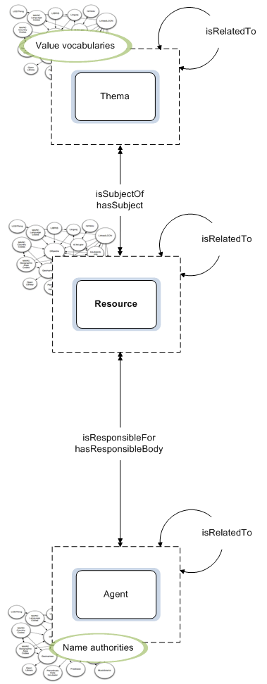 | 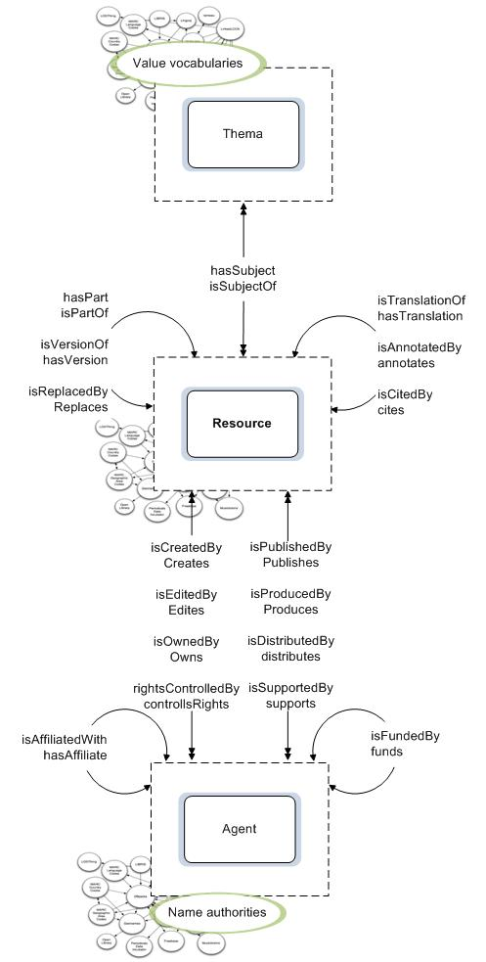
Figure 2. A general concept model | Figure 3. The implication of the general concept model  in the VOA3R case.

The general model conveys the following meanings (entity names are presented in italics):

- The Resource entity is the centre of every description. It is the starting point of any description of a resource instance. This position is set up according to the main purpose of this report. If the purpose were for building an authority file or a value vocabulary, the model would have had different emphasis.
- Relationships are established between the Resource entity and two other major entitles: Agent and Thema. Agents are responsible bodies for the creation of the content and the dissemination of the resource. Themas are usually characterized as subjects, topics, concepts, and categories that the resource’s content is about. The model does not exemplify the types of sub-entities, e.g., the sub-entities of Resource would be various resource types;
- Relationships between instances of each entity also exist. For example, a resource may be related to another resource. An agent may be related to another agent. Such relationships are demonstrated in Figure 3.
- The responsible bodies, regardless of their roles in relation to a resource, should be managed through name authority files. Concepts, topics, and geographic places as the themas of a resource should be controlled with value vocabularies. Although not emphasized in the model for the authority control of the titles of bibliographic resource given the context of this report, it is also a logical step that resource uniform titles also be controlled.
- More and more name authority files, controlled vocabularies, and resource data sets are becoming available as Linked Data. The model intentionally sets a LOD cloud background to each entity, to remind the reality.

The LODE-BD concept model holds the key for sharing the common understanding of the important entities and relationships for bibliographic data. It can be implemented to different data models and be realized with different implementation approaches. It can also be used to mark the responsibilities of internal, external, and collaborative responsibilities, the focuses of each stage of a LOD-enabled project, and the gaps between the goal and reality.

2.3 Groups of Common Properties
Common properties for describing bibliographic resources are identified and grounded in nine groups. They form the backbone of the LODE-BD Recommendations. About two dozen properties used for describing a bibliographic resource as well as an additional two sets of properties for describing relations between bibliographic resources or between agents are included. The inclusion of these properties and the grouping of them are based on the analysis of the data dictionaries and sample records provided by the data providers participating in the VOA3R project, with a supporting conceptual model.

In the following list of the groups, some selected properties are emphasized in italic format. In the report the word ‘resource’ is used to represent ‘bibliographic resource’, a primary resource type to be described.

- Title Information
Title is one of the most important and relevant access points for any resource. The information is usually supplied through a number of properties including title, alternative title-(handling subtitle(s), parallel title(s), translated title(s), transliterated title(s)), and title supplement.

- Responsible Body
This group contains the properties associated with any agent who is responsible of the creation and publication of the content of the resource, for example, the creator, contributor, and publisher or issuer.

- Physical Characteristics
Properties that describe the appearance and the characteristics of the physical form of a resource are placed into this group. They are: date, identifier, language, format, and edition/version.

- Location (physical location)
It is considered important for a resource to be located and obtained in the information exchange. As this information has been supplied by all participating data providers, properties that record the location and availability information are taken account in this unique group.

- Subject
In contrast to the physical characteristics, the Subject group embraces the properties that describe or otherwise help the identification of what the resource is about or denotes, in the form of subject term, classification/category, freely assigned keyword and geographic term.

- Description of content
Two major types of descriptions that focus on the content of the resource rather than the physical object are considered in this group: a) any representative description of the content, usually in the form of abstract, summary, note, and table of contents and b) type or genre of the resource.

- Intellectual property
Any property that deals with an aspect of intellectual property rights relating to access and use of a resource is included in this group, with special regard to rights, terms of use and access condition.

- Usage
Properties that are related to the use of a resource, rather than the characteristics of the resource itself, are considered to belong to this group. Typical properties are: audience, literary indication, and education Level.

- Relation
This group has a different perspective for describing the resources from other groups that focus on describing the resource itself. Here various relations between two resources or between two agents are the focus of description. Due to the significant number of such properties, no specific properties are listed under the Relation group in the following table. Details of the properties designed for describing the relations are introduced in the sections 9.1 and 9.2 of the recommendations.
Table 1 enumerates the common properties of each group, comprising the following components:

- Groups of properties (refer to the explanations in the section above.)
- Properties included in each group Two special styles are used to signify the importance of the properties: two plus signs “++” (also in red colour) for the mandatory property; one plus sign “+” (also in blue colour) for the highly recommended property in the context of bibliographic information exchange. The rest are recommended or optional.
- Requirements of properties in the context of non-analytical and analytical bibliographic records, specified with (M)andatory, (H)ighly-(R)ecommended, (R)ecommended, and (O)ptional marked for either process.
- Recommendation on the control of values, indicating (n)ot controlled or should be controlled by using a name authority and a controlled vocabulary or by following a syntax encoding.
- Attributes associated with individual properties, with special regard to the language and scheme attributes. A scheme can be either a value encoding scheme or a syntax encoding scheme.
Table 1. Groups of Common Properties

A | B | C |  | D | E
Group | Property | Requirement  | M | HR | R | O | |  | Value Control | Important Attributes
Group | Property | Non Analytical | Analytical | Value Control | Important Attributes
1. Title Information | title++ | M | M | n | language
1. Title Information | alternative title | O | O | n | language
1. Title Information | title supplement | O | O | n | language
2. Responsible Body | creator+ | HR | HR | n or Name authority (personal, corporate body, conference) | scheme
2. Responsible Body | contributor | O | O | n or Name authority | scheme
2. Responsible Body | publisher/issuer+ | HR | R | n or Name authority | scheme
3. Physical Characteristics | date++ | M | M | Syntax encoding rule | scheme
3. Physical Characteristics | identifier+ | HR | HR | Syntax encoding rule | scheme
3. Physical Characteristics | language++ | M | M | Controlled list | scheme
3. Physical Characteristics | format/medium+ | HR | HR | Controlled list | scheme
3. Physical Characteristics | edition /version | R | R | n
3. Physical Characteristics | source+ | HR | R | n
4. Location | location++ | M | M | n or Rule  [Holding unit names may be managed through a controlled list]
4. Location | availability | O | O | n
5. Subject | subject term+ | HR | HR | Controlled vocabulary | language  scheme
5. Subject | classification | O | O | Controlled vocabulary, Classification system | scheme
5. Subject | [freely assigned] keyword | R | R | n | language
5. Subject | geographic term | O | O | Controlled vocabulary | language  scheme
6. Description of content | description/abstract (or note/ summary/ table of contents) | R | R | n | language
6. Description of content | type/form/genre | R | R | Controlled vocabulary | language  scheme
7. Intellectual property | rights+  term of use  access condition | R | R | n [Rights holders may be managed through name authorities]
8. Usage | audience | O | O | Controlled list | scheme
8. Usage | literary indication | O | O | Controlled list | scheme
8. Usage | education level | O | O | Controlled list | scheme
9. Relation | [relation between resources]+ | O | HR | Controlled resource IDs
9. Relation | [relation between agents] | O | O | n or Name authority

2.4 Metadata Standards Used in the LODE-BD Recommendations
A selected number of widely-used metadata standards and the emerging LOD-enabled vocabularies are used as the base for the metadata terms recommended in LODE. The descriptions of these specifications are based on the information available on their Websites.

dc
Dublin Core Metadata Element Set (DCMES or DC)
Dublin Core Metadata Initiative (DCMI)
http://dublincore.org/documents/dces/
= ISO 15836
The Dublin Core Metadata Element Set is a vocabulary of fifteen properties for use in resource description. The fifteen Dublin Core elements in this standard are part of a larger set of metadata vocabularies and technical specifications maintained by the Dublin Core Metadata Initiative (DCMI).

dcterms
DCMI Metadata Terms
Dublin Core Metadata Initiative (DCMI)
http://dublincore.org/documents/dcmi-terms/
The DCMI Metadata Terms is an authoritative specification of all metadata terms maintained by DCMI. As a full set of DCMI vocabularies it also includes sets of resource classes (including the DCMI Type Vocabulary), vocabulary encoding schemes, and syntax encoding schemes.

bibo
Bibliographic Ontology
Bibliographic Ontology Specification Group
http://bibliontology.com/
The Bibliographic Ontology is designed for use in describing bibliographic things on the semantic Web in RDF. One of the usages of the ontology is to describe any kind of document in RDF, in addition to other usages such as being a citation ontology or as a document classification ontology.

agls
AGLS Metadata Standard
Australian Government Locator Service
http://www.agls.gov.au/schemas/rdfs/2008/01/15/aglsterms.rdf
= Australian Standard AS 5044-2010.
The AGLS Metadata Standard is developed to promote consistency of discovery of government resources. It provides a set of metadata properties and associated usage guidelines to improve the visibility, manageability and interoperability of online information and services.

ags
AgMES (Agricultural Metadata Element set)
FAO
http://purl.org/agmes/1.1/
AgMES is an application profile of the Dublin Core Metadata Element Set in the domain of agriculture with respect to description, resource discovery, interoperability and data exchange for different types of information resources.

eprint
Eprints Terms
UKOLN, JIST
The Eprints Terms include eprints-specific metadata properties and encoding schemes that have been created as part of the Dublin Core-based Scholarly Works Application Profile.

marcrel
MARC List for Relators
Library of Congress
LOD version: http://id.loc.gov/vocabulary/relators/fnd.html
Homepage: http://www.loc.gov/marc/relators/relators.html
Relator terms and their associated codes are originally designed for use with the MARC records, for designating the relationship between a name and a bibliographic resource.

2.5 Explanation of Terminology
Certain terminology has been applied throughout the report. Short explanations are provided below. Please refer to Appendix A for detailed explanations of each term.
“Resource”

The term “Resource” is used in the conceptual model to denote a general entity, the Bibliographic Resource. An instance of the bibliographic resource can be an article, monograph, thesis, conference paper, research report, etc., regardless if it is in print or electronic format. The range of the ‘Resource’ is consistent with what the Dublin Core referred to as ‘resource description’. However, it is narrower than rdf:Resource where Resource is an entity of anything in the universe, or is a name of the class of everything.

In the flowcharts provided by the LODE-BD Recommendations, the ‘resource’ at the beginning oval box is an instance of the bibliographic resource.

“Metadata Terms” and “Properties”

“[metadata] elements”, “[metadata] fields”, and “attributes [of an entity]” have been widely used by the professionals who are involved in creating, designing, and implementing metadata standards. The term “properties” of resources are used in place of “elements” in the LOD report.

This document considers the process of metadata description as the description of “properties” of a resource. For example, ‘rights’ is considered as a property of a resource, hence, there is a:

Property: rights
Because there are various levels of granularity and multiple corresponding ways this property can be described, LODE-BD uses “metadata term” for a specific element provided by a metadata element set. For example, property ‘rights’ can be described by metadata terms from different namespaces:
Metadata term: dc:rights
Metadata term: dcterms:rights
Metadata term: ags:rightsStatement

“String” and “URI” as values
In this document, the words ‘string’ and ‘URI’ are used for the most commonly seen values in bibliographic data. They correspond to the terminology of RDF in the form of ‘literal’ (typically a string of characters) and ‘non-literal’.

For example, “rice” is a concept included in the AGROVOC Thesaurus, with a preferred label (in English), “Rice.” When the thesaurus is published as Linked Data, the concept is considered as a resource and is given a unique URI, http://aims.fao.org/aos/agrovoc/c_6599. This means that a URI reference is used to identify this concept as a resource.

In this situation for the property: subject, the metadata terms for encoding this property include dc:subject and dcterms:subject. Based on the definition of these metadata terms, the following examples are provided:

dc:subject Rice
dcterms:subject http://aims.fao.org/aos/agrovoc/c_6599

“URI” as a value recommend in this document represents “http URI” only.

2.6 Crosswalk of Metadata Terms
All metadata terms used in the LODE-BD Recommendations are presented in the following crosswalk table. Usually metadata terms from the DCMES (dc:) and DCMI Metadata Terms (dcterms:namespaces) are the fundamentals, while metadata terms from other namespaces are supplemented when additional needs are to be satisfied. The constraints of the metadata terms (e.g., range, domain, and relation with another property) defined by these specifications are inherited when a recommendation is made in a decision tree.

Table 2. Crosswalk of metadata terms used in the LODE-BD Recommendations

LODE-BD  Group | Metadata Terms
LODE-BD  Group | General |  |  | Narrower
LODE-BD  Group | dc:-based |  | dcterms:-based
1. Title Information | dc:title |  | dcterms:title | dcterms:alternative
1. Title Information |  |  | dcterms:title | ags:titleSupplement
2. Responsible Body | dc:creator |  | dcterms:creator | ags:creatorPersonal
2. Responsible Body |  |  | dcterms:creator | ags:creatorCorporate
2. Responsible Body |  |  | dcterms:creator | ags:creatorConference
2. Responsible Body | dc:contributor |  | dcterms:contributor | bibo:editor
2. Responsible Body | dc:publisher |  | dcterms:publisher | bibo: issuer
2. Responsible Body |  |  | dcterms:publisher | bibo:producer
2. Responsible Body |  |  | dcterms:publisher | bibo:distributor
2. Responsible Body |  |  | dcterms:publisher | bibo:owner
3. Physical Characteristics | dc:date |  | dcterms:date | dcterms:created
3. Physical Characteristics |  |  | dcterms:date | dcterms:dateAccepted
3. Physical Characteristics |  |  | dcterms:date | dcterms:dateCopyrighted
3. Physical Characteristics |  |  | dcterms:date | dcterms:dateSubmitted
3. Physical Characteristics |  |  | dcterms:date | dcterms:modified
3. Physical Characteristics |  |  | dcterms:date | dcterms:valid
3. Physical Characteristics |  |  | dcterms:date | dcterms:available
3. Physical Characteristics |  |  | dcterms:date | dcterms:issued
3. Physical Characteristics | dc:identifier |  | dcterms:identifier | bibo:asin
3. Physical Characteristics |  |  | dcterms:identifier | bibo:coden
3. Physical Characteristics |  |  | dcterms:identifier | bibo:doi
3. Physical Characteristics |  |  | dcterms:identifier | bibo:eanucc13
3. Physical Characteristics |  |  | dcterms:identifier | bibo:eissn
3. Physical Characteristics |  |  | dcterms:identifier | bibo:gtin14
3. Physical Characteristics |  |  | dcterms:identifier | bibo:handle
3. Physical Characteristics |  |  | dcterms:identifier | bibo:isbn
3. Physical Characteristics |  |  | dcterms:identifier | bibo:issn
3. Physical Characteristics |  |  | dcterms:identifier | bibo:lccn
3. Physical Characteristics |  |  | dcterms:identifier | bibo:oclcnum
3. Physical Characteristics |  |  | dcterms:identifier | bibo:pmid
3. Physical Characteristics |  |  | dcterms:identifier | bibo:sici
3. Physical Characteristics |  |  | dcterms:identifier | bibo:upc
3. Physical Characteristics |  |  | dcterms:identifier | bibo:uri
3. Physical Characteristics | dc:language |  | dcterms:language
3. Physical Characteristics | dc:format |  | dcterms:format | dcterms:medium
3. Physical Characteristics | bibo:edition
3. Physical Characteristics | bibo:status
3. Physical Characteristics | dc:source |  | dcterms:source | bibo:pages | bibo:pageStart
 |  |  |  |  | bibo:pageEnd
3. Physical Characteristics |  |  | dcterms:source | bibo:section
3. Physical Characteristics |  |  | dcterms:source | bibo:volume
3. Physical Characteristics |  |  | dcterms:source | bibo:issue
3. Physical Characteristics |  |  | dcterms:source | bibo:chapter
4. Location | agls:availability |  |  | ags:availabilityLocation |  | bibo:locator
4. Location |  |  |  | ags:availabilityNumber
5. Subject |  | dc:subject | dcterms:subject | ags:subjectThesaurus
 |  | dc:subject | dcterms:subject | ags:subjectClassification
 |  | dc:coverage | dcterms:coverage | dcterms:spatial
 |  | dc:coverage | dcterms:coverage | dcterms:temporal
6. Description of content |  | dc:description | dcterms:description | dcterms:abstract
 |  | dc:description | dcterms:description | dcterms:tableOfContent
 |  | dc:type | dcterms:type
7. Intellectual property |  | dc:rights | dcterms:rights | dcterms:rightsHolder
 |  | dc:rights | dcterms:rights | dcterms:accessRights
 |  | dc:rights | dcterms:rights | dcterms:license
 |  | dc:rights | dcterms:rights | ags:rightsStatement
 |  | dc:rights | dcterms:rights | ags:termsOfUse
8. Usage |  |  | dcterms:audience | dcterms:educationLevel
 |  |  | dcterms:audience | dcterms:mediator
 |  |  | dcterms:instructionalMethod
9. Relation  [between resources] |  | dc:relation | dcterms:relation | dcterms:isVersionOf
 |  | dc:relation | dcterms:relation | dcterms:hasVersion
 |  | dc:relation | dcterms:relation | dcterms:isReplacedBy
 |  | dc:relation | dcterms:relation | dcterms:replaces
 |  | dc:relation | dcterms:relation | dcterms:isRequiredBy
 |  | dc:relation | dcterms:relation | dcterms:requires
 |  | dc:relation | dcterms:relation | dcterms:isPartOf
 |  | dc:relation | dcterms:relation | dcterms:hasPart
 |  | dc:relation | dcterms:relation | dcterms:isReferencedBy
 |  | dc:relation | dcterms:relation | dcterms:references
 |  | dc:relation | dcterms:relation | ags:relationTranslationOf
 |  | dc:relation | dcterms:relation | ags:relationHasTranslation
 |  | dc:relation | dcterms:relation | bibo:annotates
 |  | dc:relation | dcterms:relation | bibo:citedBy
 |  | dc:relation | dcterms:relation | bibo:cites
[between agents] |  | eprint:affiliatedInstitution
 |  | eprint:grantNumber
 |  | marcrel:FND

2.7 The Flowcharts
The LODE-BD report uses flowcharts to present the properties included in the nine groups. The flowcharts are a kind of diagrammatic representation that uses standardized symbols to portray steps and processes involved in decision making, with orders connected by flow lines with arrows. The basic shapes used in the figures follow the flowchart conventions:
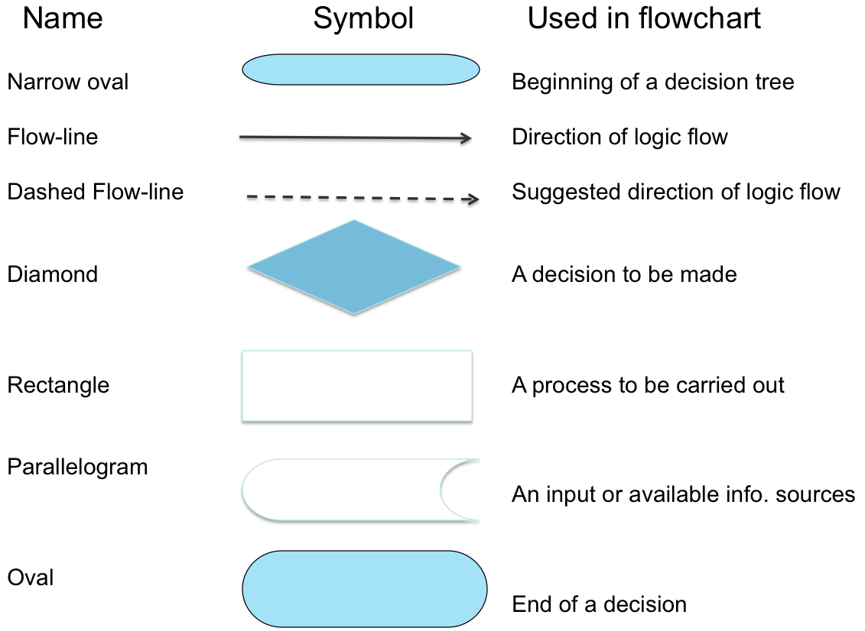

Figure 4. Flowchart symbols and meanings

Starting from the property that describes a resource instance, a flowchart presents decision points and gives a step-by-step solution to a given problem of metadata encoding. These flowcharts are designed to facilitate the selection of the appropriate strategies adjustable to data providers according to their situations, while all work towards the goal of data exchange and reuse. At the end of each flowchart there are alternative sets of metadata terms for selection.
Each chart is followed by the text-based explanations corresponding to the flowchart, with notes, steps in tables, and examples whenever necessary.

3. The Recommendations

The decision trees are presented according to the property groups:

1. Title
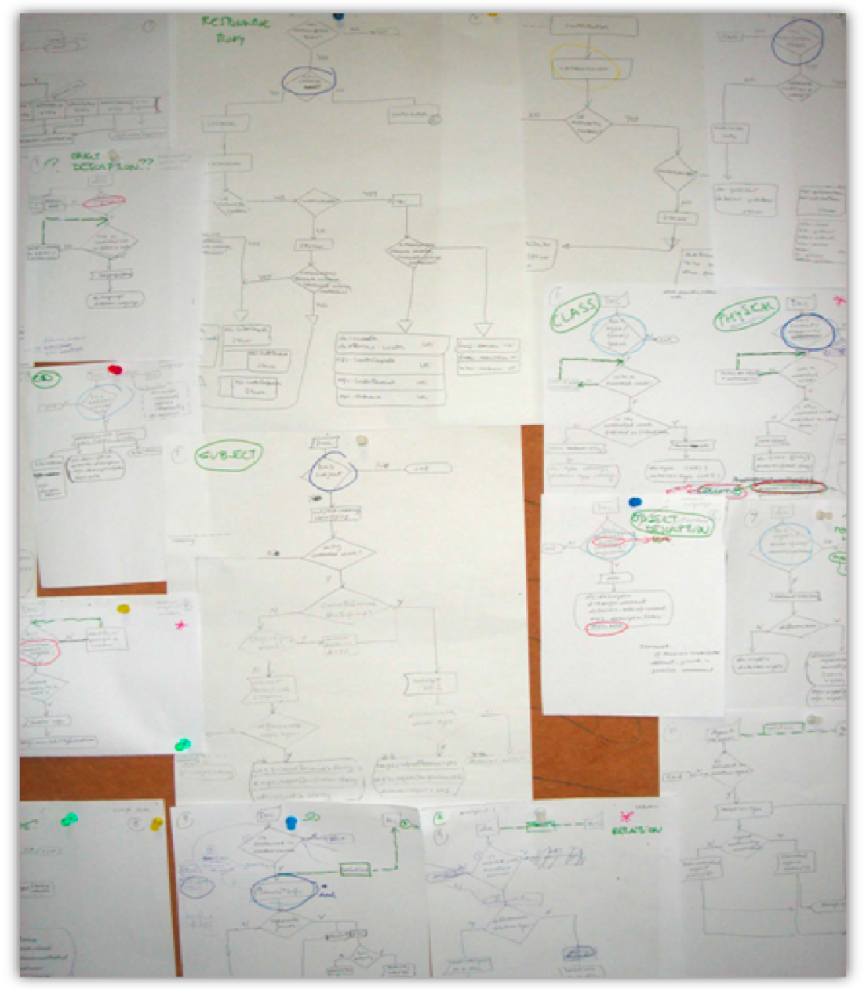
[2. Responsible Body]
2.1. Responsible Body. Creator
2.2. Responsible Body. Contributor
2.3. Responsible Body. Publisher
[3. Physical Characteristics]
3.1. Physical Characteristics. Date
3.2. Physical Characteristics. Identifier
3.3. Physical Characteristics. Language
3.4. Physical Characteristics. Format
3.5. Physical Characteristics. Edition/Version
3.6. Physical Characteristics. Source
4. Location
5. Subject
[6. Descriptions of Content]
6.1. Description of Content. Description/Abstract
6.2. Description of Content. Type/Form/Genre
7. Intellectual property
8. Usage
[9. Relation]
9.1. Relation Between Resources
9.2. Relation Between Agents

Figure 5. Brainstorming the decision-making trees
Decisions related to various situations are numbered in the flowcharts and tables for every property in the next part of the report. For each decision, find your situation according to the question and select an action.

1. Title

Relation with a resource being described: Resource has title.
Title is considered as essential in the description of resources, therefore the flowchart below foresees title as a mandatory metadata property.

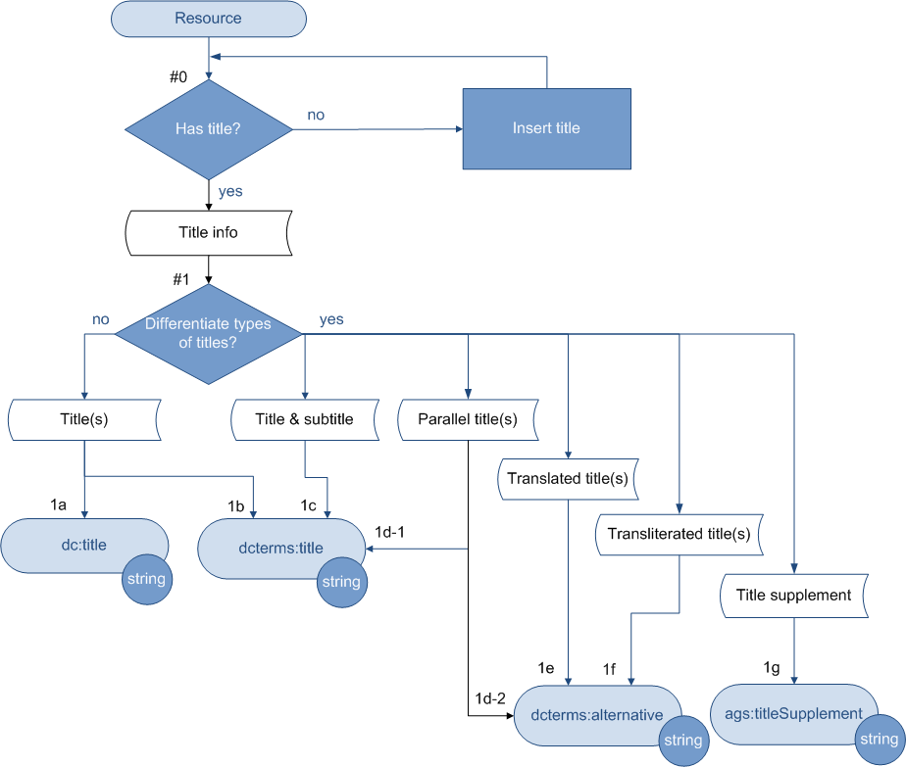

Note
- Values for this property are always text strings.
- Although not emphasized in this report for the authority control of the titles of bibliographic resource given the context of this report, it is a logical step that resource titles, especially uniform titles, also be controlled.

Decision | Question | Answer |  | Action | Value Type | Examples
 |  |  |  |  |  | Metadata Term | Value
#0 | Has title? | No |  | Insert title and go back to #0
#0 | Has title? | Yes |  | Continue to #1
#1 | Differentiate types of titles? | No |  | 1a | String | dc:title | Solar radiation energy and its utilization by Lucerne (Medicagosativa L.)  On the state of man [world agricultural situation]
#1 | Differentiate types of titles? |  |  | 1b | String | dcterms:title
#1 | Differentiate types of titles? | Yes | title(s) and subtitle(s) | 1c | String | dc:title | FAO yearbook of forest products, 1996-2000
#1 | Differentiate types of titles? | Yes | parallel title(s) | 1d-1 | String | dcterms:title | Annuaire des produits forestiers de la FAO, 1996-2000
 |  |  |  | 1d-2 | String | dcterms:alternative | Annuaire des produits forestiers de la FAO, 1996-2000
#1 | Differentiate types of titles? | Yes | translated title(s) | 1e | String | dcterms:alternative | Anuario de productos forestales de la FAO, 1996-2000  Working together for an International Alliance Against Hunger
#1 | Differentiate types of titles? | Yes | transliterated title(s) | 1f | String | dcterms:alternative | Posly dobroj voli Prodovol'stvennoj i Sel'skokhozyajstvennoj Organizatsii Ob'edinennykh Natsij
#1 | Differentiate types of titles? | Yes | title supplement | 1g | String | ags:titleSupplement | Report of a WHO Expert Consultation in collaboration with The Institute for Hygiene and Food Safety of the Federal Dairy Research Center, The Food and Agriculture Organization of the United Nations, Kiel, Germany, 21-23 March 2000

[2. Responsible Body]

2.1 Creator

Relation with a resource being described: Resource has creator.

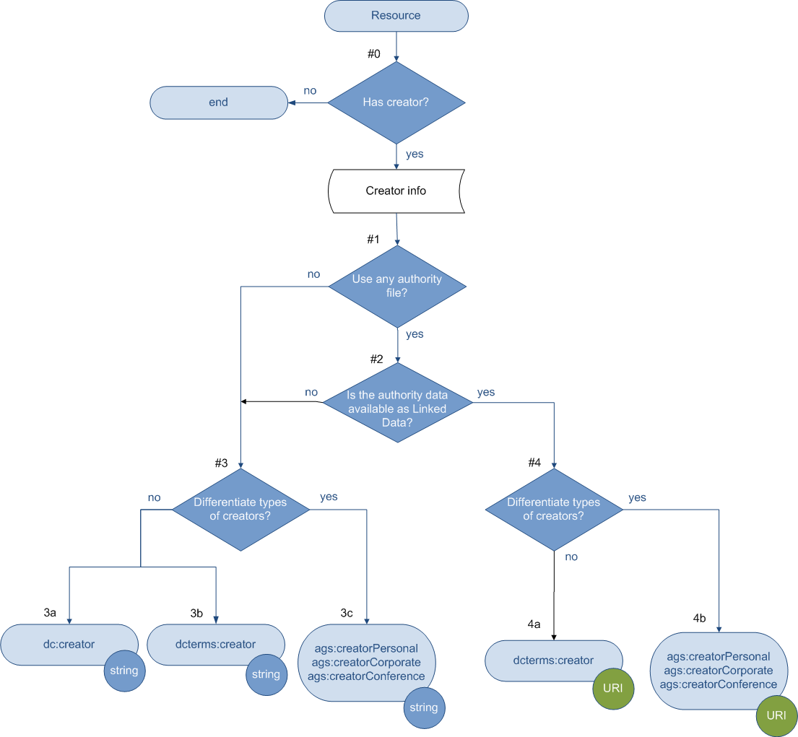

Note

- It is always recommended that an authority file be used for the responsible body that has created the resource.
- In the examples below, the names of corporate body and conference are in English. Both the strings and the URIs are from the FAO Authority Description Concept Scheme.

Decision | Question | Answer | Action | Value Type | Examples
 |  |  |  |  | Metadata Term | Value
#0 | Has creator? | No | End
#0 | Has creator? | Yes | Continue to #1
#1 | Use any authority file? | No | Go to #3  [Unauthorized form for any responsible body]
#1 | Use any authority file? | Yes | Go to #2
#2 | Is the authority data available as Linked Data? | No | Go to #3  [Authorized form from an authority file]
#2 | Is the authority data available as Linked Data? | Yes | Go to #4
#3 | Differentiate types of creators? | No | 3a | String | dc:creator | [Unauthorized form]:  Tim Berners-Lee  Tim B-L  Timothy John Berners-Lee  FAO of the UN  FAO Council (78th Session) Nov. 24,  1980, Rome, Italy  [Authorized form ]:  Berners-Lee, Tim  FAO Council (Sess. 78 : 24 Nov 1980  : Rome, Italy)  Food and Agriculture Organization of  the United Nations
#3 | Differentiate types of creators? | No | 3b | String | dcterms:creator
#3 | Differentiate types of creators? | Yes | 3c | String | ags:creatorPersonal | [Unauthorized form]  Tim Berners-Lee  [Authorized form ]:  Berners-Lee, Tim
 |  |  |  |  | ags:creatorCorporate | [Unauthorized form]:  FAO of the UN  [Authorized form ]:  Food and Agriculture Organization of  the United Nations
 |  |  |  |  | ags:creatorConference | [Unauthorized form]:  FAO Council (78th Session) Nov. 24,  1980, Rome, Italy  [Authorized form ]:  FAO Council (Sess. 78 : 24 Nov 1980  : Rome, Italy)

#4 | Differentiate types of creators? | No | 4a | URI | dcterms:creator | http://aims.fao.org/aos/corporate/c_1297 [1]  http://aims.fao.org/aos/conference/c_1842[2]  http://viaf.org/viaf/85312226/#Berners-Lee,_Tim [3]  http://www.w3.org/People/Berners-Lee/card [4]
#4 | Differentiate types of creators? | Yes | 4b | URI | ags:creatorPersonal | http://viaf.org/viaf/85312226/#Berners-Lee,_Tim [3]  http://www.w3.org/People/Berners-Lee/card [4]
 |  |  |  |  | ags:creatorCorporate | http://aims.fao.org/aos/corporate/c_1297 [1]
 |  |  |  |  | ags:creatorConference | http://aims.fao.org/aos/conference/c_1842 [2]

[1] A corporate body’s URI, from the FAO Authority Description Concept Scheme
[2] A conference’ URI, from the FAO Authority Description Concept Scheme
[3] Tim Berners-Lee’s URI, from the FIAF (Virtual International Authority File)
[4] Tim Berners-Lee’s URI: http://www.w3.org/People/Berners-Lee/card#i (Source of note: http://www.linkedin.com/in/timbl)

2.2 Contributor

Relation with a resource being described: Resource has contributor.

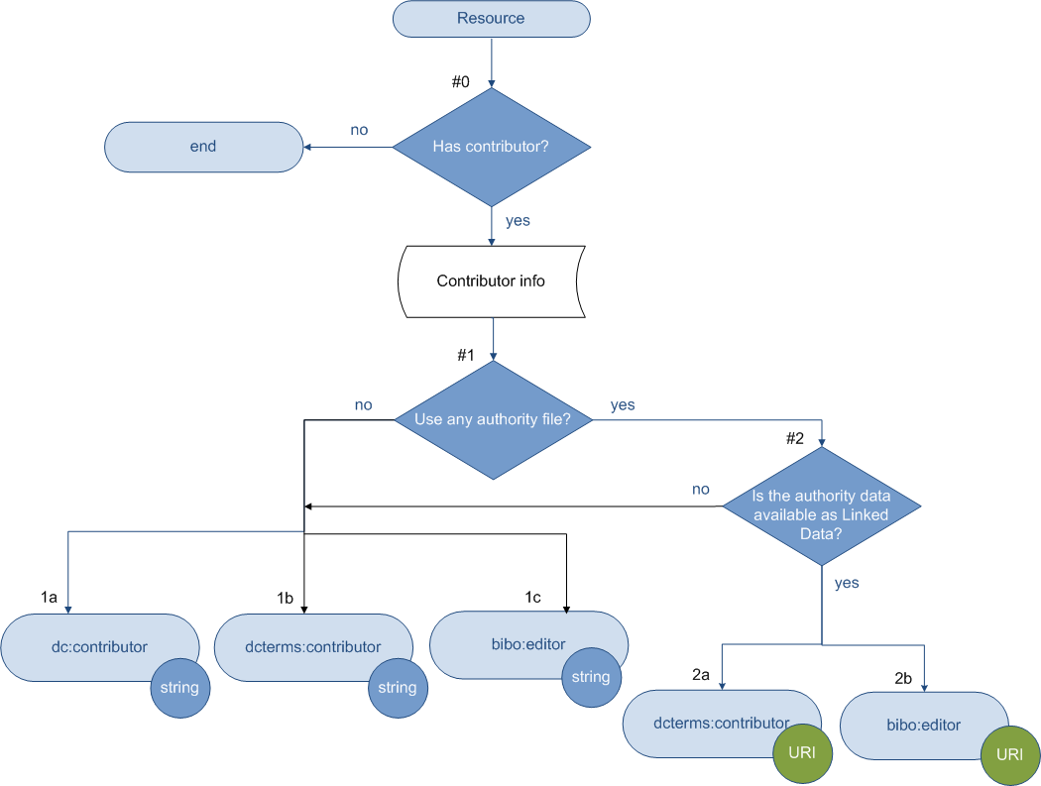

Note
- It is always recommended that an authority file be used for a responsible body that has contributed to the resource.

Decision | Question | Answer | Action | Value Type | Examples
 |  |  |  |  | Metadata Term |  | Value
#0 | Has contributor? | No | End
#0 | Has contributor? | Yes | Continue to #1
#1 | Use any authority file? | No | 1a | String | dc:contributor |  | [Unauthorized form]:  Tim Berners-Lee  Tim B-L  FAO of the UN  FAO Council  (78thSession) Nov. 24,  1980, Rome, Italy  [Authorized form ]:  Berners-Lee, Tim  Food and Agriculture  Organization of the  United Nations
#1 | Use any authority file? | No | 1b | String | dcterms:contributor
#1 | Use any authority file? | No | 1c | String | bibo:editor
#1 | Use any authority file? | Yes | Go to #2
#2 | Is the authority data available as Linked Data? | No | Go to #1 Opt. No  [Use authorized form from an authority file]
#2 | Is the authority data available as Linked Data? | Yes |  |  |  | [URI of a responsible body]
#2 | Is the authority data available as Linked Data? | Yes | 2a | URI | dcterms:contributor
#2 | Is the authority data available as Linked Data? | Yes | 2b | URI | bibo:editor

2.3 Publisher

Relation with a resource being described: Resource has publisher.

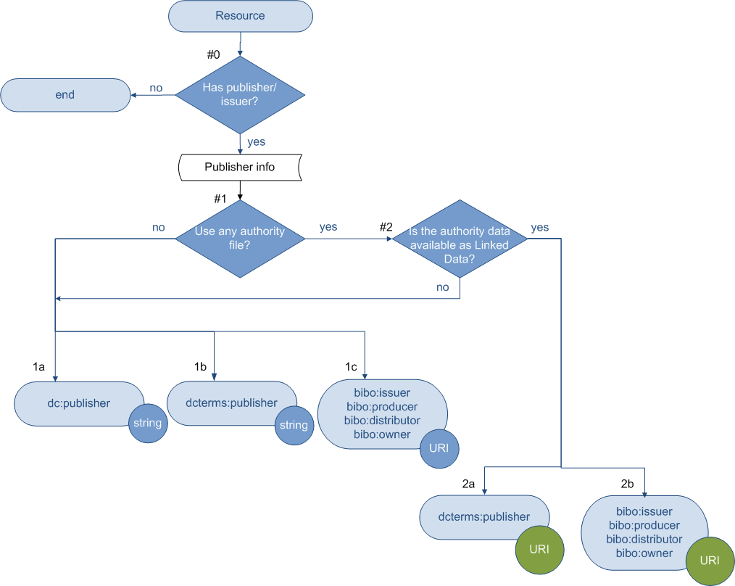

Note
- It is always recommended that an authority file be used for a responsible body that is responsible for publishing or producing the resource.

Decision | Question | Answer | Action | Value Type | Examples
 |  |  |  |  | Metadata Term | Value
#0 | Has publisher/issuer? | No | End
#0 | Has publisher/issuer? | Yes | Continue to #1
#1 | Use any authority file? | No | 1a | String | dc:publisher | [Un-authorized form] :  FAORome (Italy)  FAO  F.A.O.  FAO of the UN  FAO, Rome  Food and Agriculture  Organization  F.A.O. of the U.N.  [Authorized form] :  Food and Agriculture  Organization of the  United Nations
#1 | Use any authority file? | No | 1b | String | dcterms: publisher
#1 | Use any authority file? | No | 1c | String | bibo: issuer
 |  |  |  |  | bibo:producer
 |  |  |  |  | bibo:distributor
 |  |  |  |  | bibo:owner
#1 | Use any authority file? | Yes | Go to #2
#2 | Is the authority data available as Linked Data? | No | Go to #1 Opt. No.  [Use authorized form from an authority file]
#2 | Is the authority data available as Linked Data? | Yes | 2a | URI | dcterms: publisher | [URI of a responsible body]
#2 | Is the authority data available as Linked Data? | Yes | 2b | URI | bibo: issuer | [URI of a responsible body]
 |  |  |  |  | bibo:producer | [URI of a responsible body]
 |  |  |  |  | bibo:distributor | [URI of a responsible body]
 |  |  |  |  | bibo:owner | [URI of a responsible body]

[3. Physical Characteristics]

3.1 Date

Relation with a resource being described: Resource has date.

Date is considered essential information in the description of resources, therefore the flowchart below foresees date as a mandatory property.

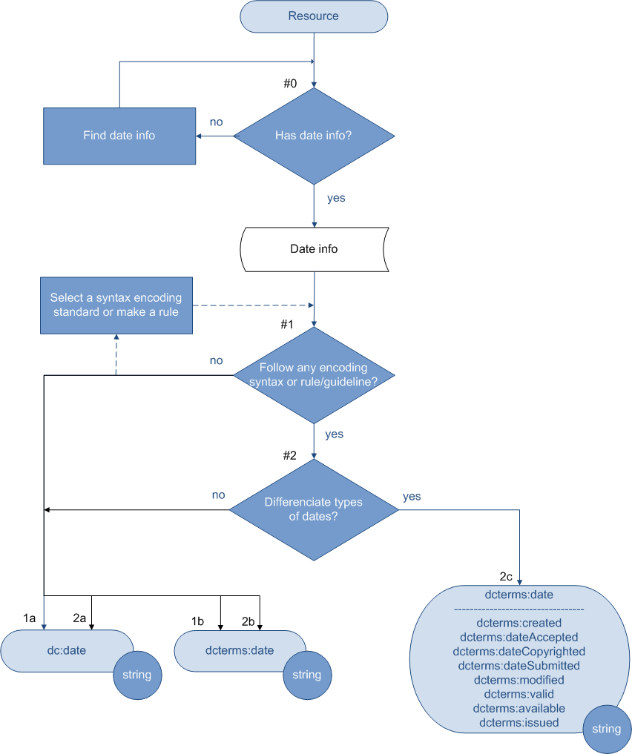

Note

- Recommended best practice is to follow an encoding syntax, such as that defined by the W3CDTF profile of ISO 8601 [W3CDTF].

Decision | Question | Answer | Action | Value Type | Examples
 |  |  |  |  | Metadata Term | Value
#0 | Has date? | No | Find date info and go back to #0
#0 | Has date? | Yes | Continue to #1
#1 | Follow any encoding syntax or rule/guideline? | Yes | Continue to #2
#1 | Follow any encoding syntax or rule/guideline? | No | 1a | String | dc:date | [198?]  [1996]  [1997?]  1968-2006  7 Jul 1989  7 July 1989  7-July-1989  Jul 1989  1989 Jul  Jan-Feb 1997  1-5 Feb 1997  Spr 1997  20 Mar - 15 Apr 1995
#1 | Follow any encoding syntax or rule/guideline? | No | 1b | String | dcterms:date | [see all examples above]
#2 | Differentiate type of dates? | No | 2a | String | dc:date | 1997  1997-07  1997-07-16  1997-07-16T19:20+01:00  1997-07-16T19:20:30+01:00  1997-07-16T19:20:30.45+01:00 [1]
#2 | Differentiate type of dates? | No | 2b | String | dcterms:date
#2 | Differentiate type of dates? | Yes | 2c | String | dcterms:date
 |  |  |  |  | dcterms:created
 |  |  |  |  | dcterms:dateAccepted
 |  |  |  |  | dcterms:dateCopyrighted
 |  |  |  |  | dcterms:dateSubmitted
 |  |  |  |  | dcterms:modified
 |  |  |  |  | dcterms:valid
 |  |  |  |  | dcterms:available
 |  |  |  |  | dcterms:issued

[1] ISO 8601.

3.2 Identifier

Relation with a resource being described: Resource has identifier.

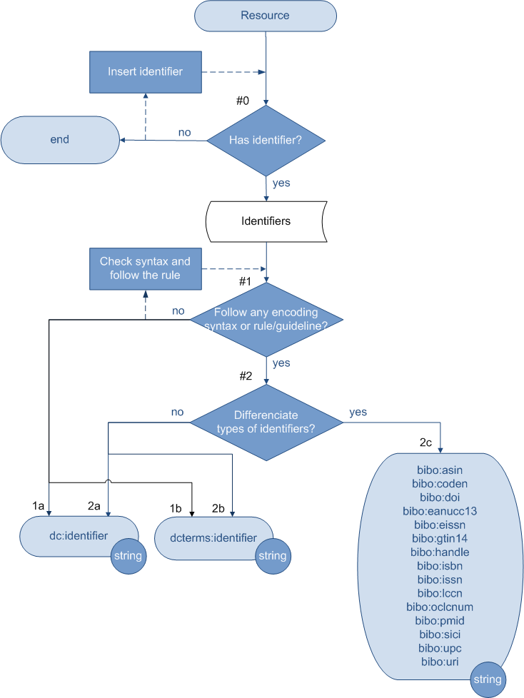
Note
- It is always recommended that a resource has an identifier or identifiers.
- *Established codes for identifiers (universal or local) should be used for any kind of identifiers. It is always recommended to check the syntax, follow or create a rule/guideline when handling identifiers.

Decision | Question | Answer | Action | Value Type | Examples
 |  |  |  |  | Metadata Term | Value
#0 | Has identifier? | No | End but recommended to insert an identifier
#0 | Has identifier? | Yes | Continue to #1
#1 | Follow any encoding syntax, or follow any rule or guideline? | No* | 1a | String | dc:identifier | http://www.ukoln.ac.uk/ [1]
 |  |  |  |  |  | urn:ietf:rfc:1766 [1]
#1 | Follow any encoding syntax, or follow any rule or guideline? | No* | 1b | String | dcterms:identifier | http://www.ukoln.ac.uk/ [1]
 |  |  |  |  |  | urn:ietf:rfc:1766 [1]
#1 | Follow any encoding syntax, or follow any rule or guideline? | Yes | Continue to #2
#2 | Differentiate types of identifiers? | No | 2a | String | dc:identifier | http://www.ukoln.ac.uk/ [1]
 |  |  |  |  |  | urn:ietf:rfc:1766 [1]
#2 | Differentiate types of identifiers? | No | 2b | String | dcterms:identifier | http://www.ukoln.ac.uk/ [1]
 |  |  |  |  |  | urn:ietf:rfc:1766 [1]
#2 | Differentiate types of identifiers? | Yes | 2c | String | bibo:asin | 020530902X [2]
 |  |  |  |  | bibo:coden | 66HYAL [3]
 |  |  |  |  | bibo:doi | doi:10.1109/ISSTA.2002.1048560 [4]
 |  |  |  |  | bibo:eanucc13 | 0123456789012 [5]
 |  |  |  |  | bibo:eissn | 0378-5955 [6]
 |  |  |  |  | bibo:gtin14 | 00012345600012 [7]
 |  |  |  |  | bibo:handle | http://hdl.handle.net/10760/6634 [8]
 |  |  |  |  | bibo:isbn | 9-788175-257665 [9]
 |  |  |  |  |  | 9788175257665
 |  |  |  |  | bibo:issn | 0317-8471 [10]
 |  |  |  |  | bibo:lccn | 79051955 [11]
 |  |  |  |  | bibo:oclcnum | ocm00012345 [12]
 |  |  |  |  |  | ocn123456789
 |  |  |  |  | bibo:pmid | 20346624 [13]
 |  |  |  |  | bibo:sici | 0095-4403(199502/03)21:3  <12:WATIIB>2.0.TX;2-J [14]
 |  |  |  |  | bibo:upc | 5778400002 [15]
 |  |  |  |  | bibo:uri | http://example.org/absolute/URI/with/  absolute/path/to/resource.txt [16]
 |  |  |  |  |  | ftp://example.org/resource.txt

[1] From http://dublincore.org/documents/2001/04/12/usageguide/simple-html.shtml
[2] From http://en.wikipedia.org/wiki/Amazon_Standard_Identification_Number
[3] From http://en.wikipedia.org/wiki/CODEN
[4] From http://www.doi.org/
[5] From http://www.gtin.info/
[6] From http://en.wikipedia.org/wiki/EISSN
[7] From http://www.gtin.info/
[8] From http://eprints.rclis.org/
[9] From http://en.wikipedia.org/wiki/International_Standard_Book_Number
[10] From http://en.wikipedia.org/wiki/International_Standard_Serial_Number
[11] From http://catalog.loc.gov/
[12] From http://www.oclc.org/batchprocessing/controlnumber.htm
[13] From http://www.ncbi.nlm.nih.gov/pubmed/
[14] From http://en.wikipedia.org/wiki/Serial_Item_and_Contribution_Identifier
[15] From http://en.wikipedia.org/wiki/Universal_Product_Code
[16] From http://en.wikipedia.org/wiki/Uniform_Resource_Identifier

3.3 Language

Relation with a resource being described: Resource has language information.

Language is considered essential information in the description of resources, therefore the flowchart below foresees language as a mandatory property.

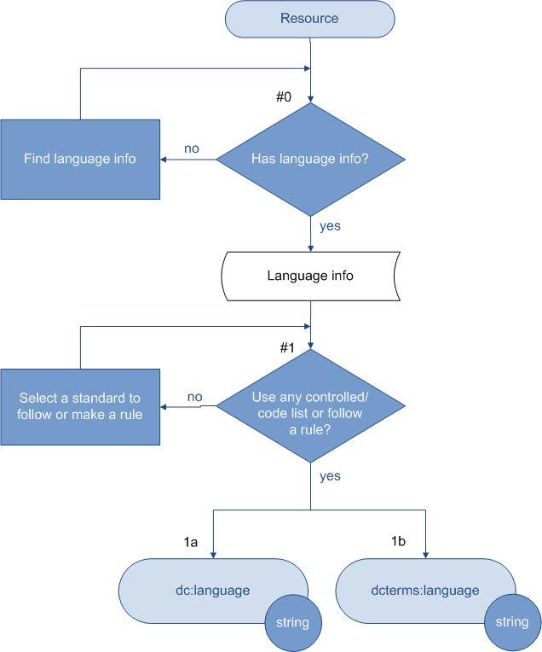

Note
- Recommended best practice is to use an encoding scheme, such as the three-letter code (ISO639-2) or the two letter code (ISO639-1).

Decision | Question | Answer | Action | Value Type | Examples
 |  |  |  |  | Metadata Term | Value
#0 | Has language info? | No | Find language info and go back to #0
#0 | Has language info? | Yes | Continue to #1
#1 | Use any controlled list /code list or follow a rule? | No | Go back to #1
#1 | Use any controlled list /code list or follow a rule? | Yes | 1a | String | dc:language | cat [1]
 |  |  |  |  |  | ca [2]
#1 | Use any controlled list /code list or follow a rule? | Yes | 1b | String | dcterms:language | cat [1]
 |  |  |  |  |  | ca [2]

[1] From ISO639-2
[2] From ISO639-1

3.4 Format

Relation with a resource being described: Resource has format.

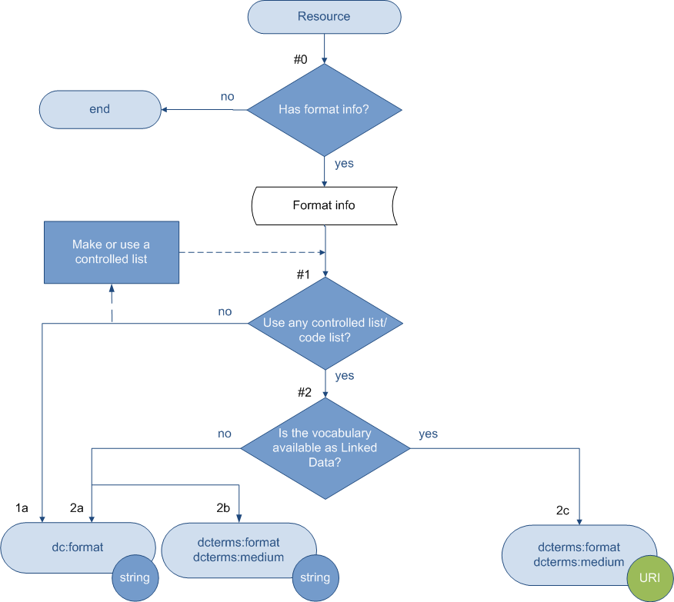

Note
- *It is always recommended that a controlled vocabulary be created for your collection when describing ‘format’, such as the list of Internet Media Types [MIME].
- dcterms:medium has the definition of material or physical carrier of the resource such as a book or CD. Therefore the Internet Media Types [MIME] should not be used for these values. [1]

Decision | Question | Answer | Action | Value Type | Examples
 |  |  |  |  | Metadata Term | Value
#0 | Has format info? | No | End
#0 | Has format info? | Yes | Continue to #1
#1 | Use any controlled list or code list? | No* | 1a | String | dc:format | html
#1 | Use any controlled list or code list? | Yes | Continue to #2
#2 | Is the controlled vocabulary available as Linked Data? | No | 2a | String | dc:format | text/html
#2 | Is the controlled vocabulary available as Linked Data? | No | 2b | String | dcterms:format | text/html
 |  |  |  |  | dcterms:medium | CD  Book
#2 | Is the controlled vocabulary available as Linked Data? | Yes | 2c | URI | dcterms:format | [URI of a term]
 |  |  |  |  | dcterms:medium | [URI of a term]

[1] according to: http://web.resource.org/rss/1.0/modules/dcterms/#extent

3.5 Edition/Version

Decisions related to various situations are numbered in the table and flowchart below. For each decision, find your situation according to the question and select an action.

Relation with a resource being described: Resource has edition/version/status.

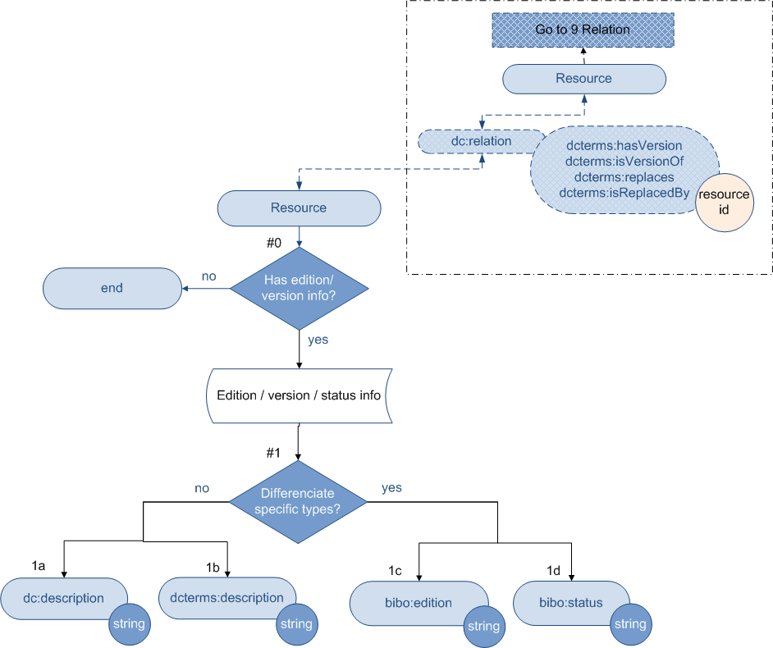

Notes
- When edition or version of a resource is to be described, the relation between a resource and its related version(s) should also be described. In this graph, a dash-lined box signifies such relation(s) and points to Section 9, “Relation”, in this report.
- The main body of the graph is only focused on the description of edition or version as a part of the physical characteristics of a resource. For describing relations between different versions of resources, go to Section 9.1 Relations between resources.

Decision | Question | Answer | Action | Value Type | Examples
 |  |  |  |  | Metadata Term | Value
#0 | Has edition version info | No | End
#0 | Has edition version info | Yes | Continue to #1
#1 | Differentiate specific types? | No | 1a | String | dc:description | 2nd ed.
#1 | Differentiate specific types? | No | 1b | String | dcterms:description | 2nd ed.
#1 | Differentiate specific types? | Yes | 1c | String | bibo:edition | 2nd ed.
#1 | Differentiate specific types? | Yes | 1d | String | bibo:status | Final.

3.6 Source
Relation with a resource being described: Resource has source.

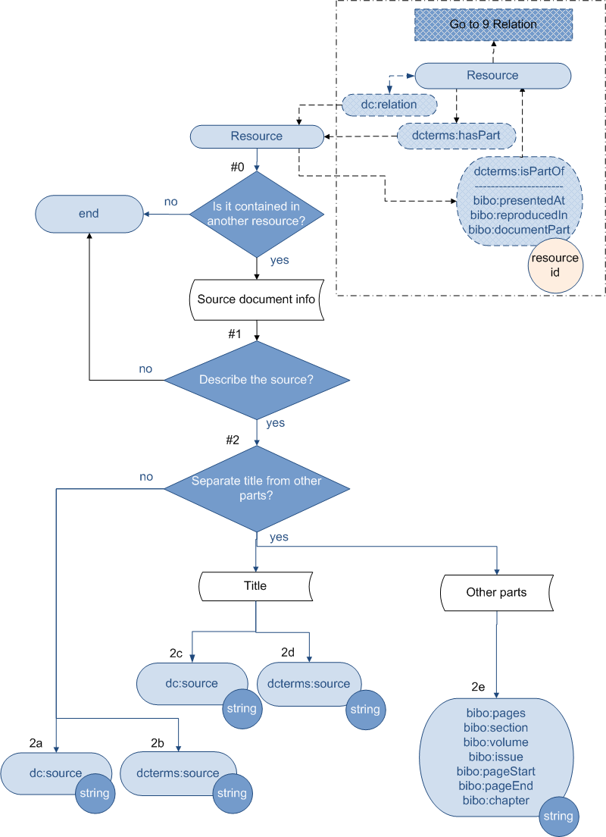

Notes
- When a resource to be described is contained in another resource, the relations between the resources may be described according to the convention of a data provider. In this graph, a dash-lined box signifies such relation(s) and points to Section 9, “Relation”.
- The main body of the graph is only focused on the description of the source of a resource. For describing relations between the resources involved, go to Section 9.1 Relations between resources.
- * It is recommended that if the resource titles are controlled through an authority file, use the controlled title or identifier.

Decision | Question | Answer | Action | Value Type | Examples
 |  |  |  |  | Metadata Term | Value
#0 | Is it contained in another source? | No | End
#0 | Is it contained in another source? | Yes | Continue to #1
#1 | Describe the source | No | End
#1 | Describe the source | Yes | Continue to #2
#2 | Separate title from other parts? | No | 2a | String | dc:source | Proceedings of the National Academy of Sciences of the United States of America, v. 95(10) p. 5632-5636
http://www.pnas.org/content/by/
year/2010

#2 | Separate title from other parts? | No | 2b | String | dcterms:source | Proceedings of the National Academy of Sciences of the United States of America, v. 95(10) p. 5632-5636
http://www.pnas.org/content/by/
year/2010

#2 | Separate title from other parts? | Yes | 2c | String  (Title)* | dc:source | Proceedings of the National Academy of Sciences of the United States of America
#2 | Separate title from other parts? | Yes | 2d | String  (Title) | dcterms:source | Proceedings of the National Academy of Sciences of the United States of America
#2 | Separate title from other parts? | Yes | 2e | String  (Other parts) | bibo:pages | 542
 |  |  |  |  | bibo:section | 2
 |  |  |  |  | bibo:volume | 95
 |  |  |  |  | bibo:issue | 10
 |  |  |  |  | bibo:pageStart | 5632
 |  |  |  |  | bibo:pageEnd | 5636
 |  |  |  |  | bibo:chapter | II

4. Location
Relation with a resource being described: Resource has holding or location information.
Location is considered essential information in the description of resources, therefore the flowchart below foresees location as a mandatory property.

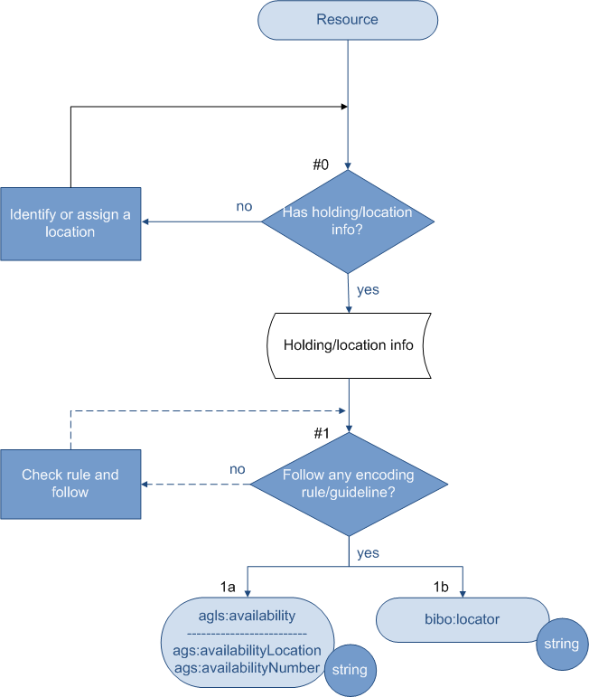
Note
- A location (physical location) is always required.
- *It is always recommended that location information is provided consistently by following an encoding rule or guideline.

Decision | Question | Answer | Action | Value Type | Examples
 |  |  |  |  | Metadata Term | Value
#0 | Has holding/location info? | No | Identify or assign a location and Go back to #0
#0 | Has holding/location info? | Yes | Continue to #1
#1 | Follow any encoding rule or guideline? | No* | Go back to #1
#1 | Follow any encoding rule or guideline? | Yes | 1a | String | agls:availability | http://www.example.org/services/id5678/  Contact the Publications Section on 1300 999 999[1]
 |  |  |  |  | ags:availabilityLocation | University of Vienna, Peter Jordanstr. 52, A-1190 Vienna, Austria
 |  |  |  |  | ags:availabilityNumber | Boku 2456.23
#1 | Follow any encoding rule or guideline? | Yes | 1b | String | bibo:locator | Box 12, Folder 3

[1] From http://www.agls.gov.au/

5. Subject

Relation with a resource being described: Resource has subject/topic.

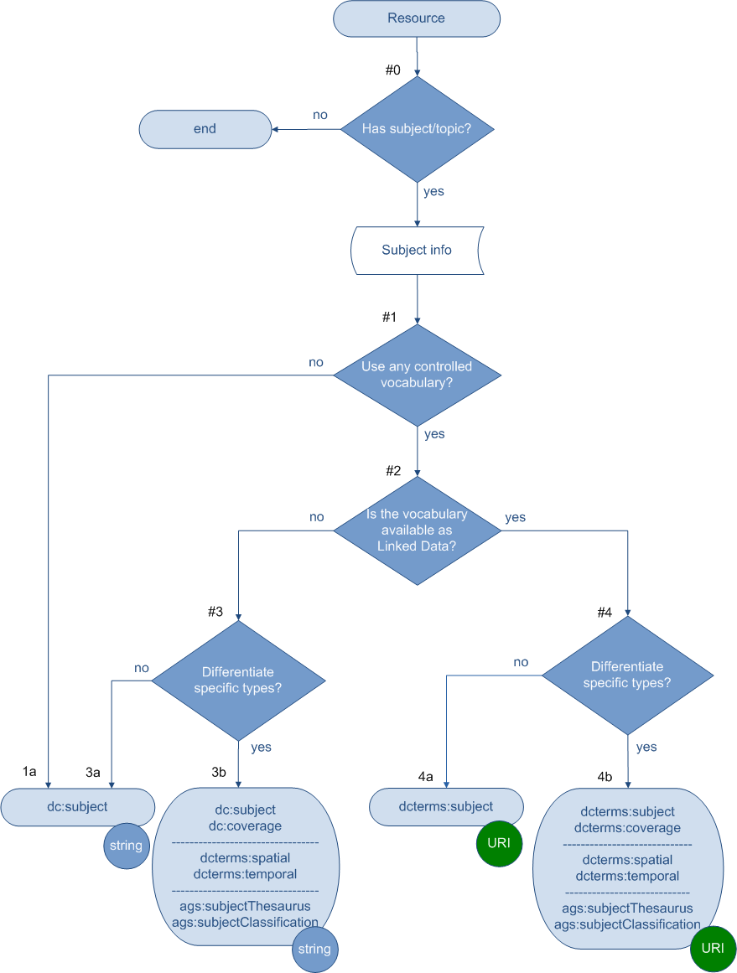

Note
- Examples in the following table are in English. Values (strings or URIs) in the examples are from the AGROVOC Thesaurus and the Library of Congress Subject Headings. Classification values (strings or URIs) in the examples are from the Dewey Decimal Classification system.
- Usually a value encoding scheme’s title (e.g., AGROVOC or LCSH) should be indicated along with the value. This report does not provide the syntax (e.g., rdf, xml, html) of expressing this related information. Consult references if needed.
- * If you plan to publish your controlled vocabulary as linked data, you may follow AGROVOC’s practice.

Decision | Question | Answer | Action | Value Type | Examples
 |  |  |  |  | Metadata Term | Value
#0 | Has subject/topics? | No | End
#0 | Has subject/topics? | Yes | Continue to #1
#1 | Use any controlled vocabulary? | No | 1a | String | dc:subject | paddy
 |  |  |  |  |  | Pacific Islands & Oceania
 |  |  |  |  |  | 19th century
#1 | Use any controlled vocabulary? | Yes | Continue to #2
#2 | Is the vocabulary available as linked data (i.e., each concept has a http URI)? | No* | Continue to #3
#2 |  | Yes | Continue to #4
#3 | Differentiate types of subjects? | No | 3a | String | dc:subject | Rice
 |  |  |  |  |  | Pacific Islands
 |  |  |  |  |  | Nineteenth century
#3 | Differentiate types of subjects? | Yes | 3b | String | dc:subject | Rice
 |  |  |  |  | dc:coverage | Pacific Islands
 |  |  |  |  | dcterms:spatial | Pacific Islands
 |  |  |  |  | dcterms:temporal | Nineteenth century
 |  |  |  |  | ags:subjectThesaurus | Rice
 |  |  |  |  | ags:subjectClassification | 586 [1]
#4 | Differentiate types of subjects? | No | 4a | URI | dcterms:subject | http://aims.fao.org/aos/  agrovoc/c_6599 [2]
http://aims.fao.org/aos/
agrovoc/c_5487 [3]
#4 | Differentiate types of subjects? | Yes | 4b | URI | dcterms:subject | http://aims.fao.org/aos/  agrovoc/c_6599 [2]
 |  |  |  |  | dcterms:coverage | http://aims.fao.org/aos/  agrovoc/c_5487 [3]
 |  |  |  |  | dcterms:spatial | http://aims.fao.org/aos/  agrovoc/c_5487 [3]
 |  |  |  |  | dcterms:temporal | http://id.loc.gov/  authorities/sh85091984 [4]
 |  |  |  |  | ags:subjectThesaurus | http://aims.fao.org/aos/  agrovoc/c_6599 [2]
 |  |  |  |  | ags:subjectClassification | http://dewey.info/class/586/ [5]

[1] From the Dewey Decimal Classification: “586 Seedless plants” (English version).
[2] http://aims.fao.org/aos/agrovoc/c_6599 is the URI of a concept in AGROVOC. Its preferred English label is “Rice”.
[3] http://aims.fao.org/aos/agrovoc/c_5487 is the URI of a concept in AGROVOC. Its preferred English label is “Pacific Islands ”.
[4] http://id.loc.gov/authorities/sh85091984 is the URI of a concept in LCSH. Its preferred English label is “Nineteenth century”.
[5] The URI of the Dewey Decimal Classification: “586”. Its English caption is “Seedless plants”.

Additional comments

1. It is always recommended to index the concept/topic/subject/category of a resource.
Examples of values:
- concepts represented by terms from a controlled vocabulary (e.g., Agrovoc, LCSH, ASFA Thesaurus.);
- keywords;
- classes or categories represented by codes or terms from a classification system.

2. If your database contains separate fields for values from a thesaurus and a classification, or wants to differentiate general subjects from geographic names, you may encode with appropriate metadata terms. See Decision #3.

3. More and more controlled vocabularies are published as Linked Data where concepts are represented by non-literal values (i.e., an identifier and/or a concept-URI). For example, each AGROVOC concept and label has its unique http URI.

Use these http URIs instead of the literal forms (i.e., the labels) as values when considering moving towards publishing your data as linked data.
Examples of values:
- an AGROVOC concept URI;
- a URI from any controlled vocabulary, e.g., LCSH;
- a URI of an agent when the agent is the subject/focus of a resource (e.g., URI of a conference, defined in a foaf file or defined in the FAO OA).

4. If you have created your own controlled vocabulary and would like to publish it as a LD value vocabulary, you may follow the AGROVOC practices.

5. If in the metadata records you have used strings from a controlled vocabulary (e,g., a subject heading from LCSH or a descriptor from AGROVOC), and now want to release your metadata as a LD set, you may convert the strings into corresponding URIs provided by this vocabulary. Please follow the instructions in Decision #4.

6. Usually a value encoding scheme’s title (e.g., ‘AGROVOC’ or ‘LCSH’) should be indicated along with the value. This document does not provide the syntax (e.g., rdf, xml, html) of expressing this related information. Consult references if needed, including:
- "Expressing Dublin Core Description Sets using XML (DC-DS-XML)"
URL: http://www.dublincore.org/documents/dc-ds-xml/
- "Expressing Dublin Core metadata using the Resource Description Framework (RDF)"
http://www.dublincore.org/documents/dc-rdf/

[6. Description of Content]

6.1 Description/Abstract

Relation with a resource being described: Resource has description/abstract.

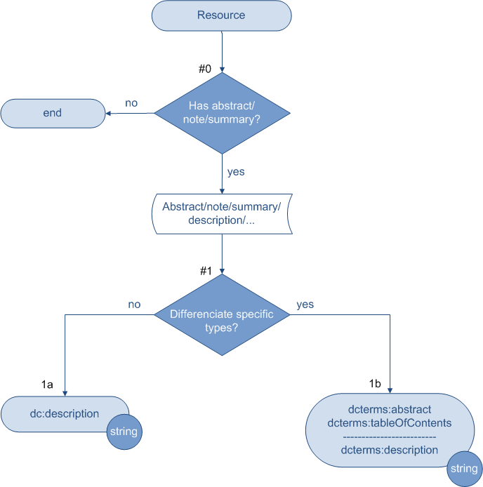

Note
- In describing the content, different words might have been used, such as ‘abstract’ vs. ‘note’, or ‘description’ vs. ‘summary’. A table of contents may also be presented in a description.
- When a translated description is to be included, repeat the actions.

Decision | Question | Answer | Action | Value Type | Examples
 |  |  |  |  | Metadata Term | Value
#0 | Has abstract/note/summary? | No | End
#0 | Has abstract/note/summary? | Yes | Continue to #1
#1 | Differentiate types of content descriptions? | No | 1a | String | dc:description | One of the least understood aspects of population biology is …
#1 | Differentiate types of content descriptions? | Yes | 1b | String | dcterms:abstract | One of the least understood aspects of population biology is …
 |  |  |  |  | dcterms:table-of-contents | Introduction -- Formal theory -- Coevolution --
 |  |  |  |  | dcterms:description | Contains a series of articles which are intended to …

6.2 Type/Form/Genre

Relation with a resource being described: Resource has type/form/genre.

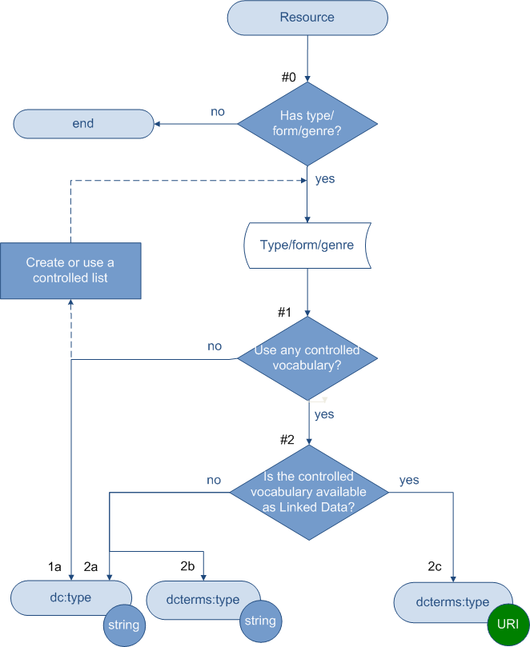

Note
- Values (strings or URIs) in the examples are from DCMI Type Vocabulary and DC Terms http://www.dublincore.org/documents/dcmi-terms/ namespace.
- * It is always recommended that a controlled vocabulary be used or created for your collection when describing a resource type. An example of such a controlled vocabulary is the “Eprint Type” list used by the Organic-Eprints.

Decision | Question | Answer | Action | Value Type | Examples
 |  |  |  |  | Metadata Term | Value
#0 | Has type/form/genre? | No | End
#0 | Has type/form/genre? | Yes | Continue to #1
#1 | Use any controlled vocabulary ? | No* | 1a | String | dc:type | Lecture; Poster, …
#1 | Use any controlled vocabulary ? | Yes | Continue to #2
#2 | Is the controlled vocabulary available as linked data? | No | 2a | String | dc:type | Interactive Resource
#2 | Is the controlled vocabulary available as linked data? | No | 2b | String | dcterms:type | Interactive Resource
#2 | Is the controlled vocabulary available as linked data? | Yes | 2c | URI | dcterms:type | http://purl.org/dc/dcmitype/ InteractiveResource [1]

[1] http://purl.org/dc/dcmitype/InteractiveResource is the URI of the concept “Interactive Resource”, from DCMI Type Vocabulary.

7. Intellectual property. Rights

Relation with a resource being described: Resource has intellectual property rights statement.

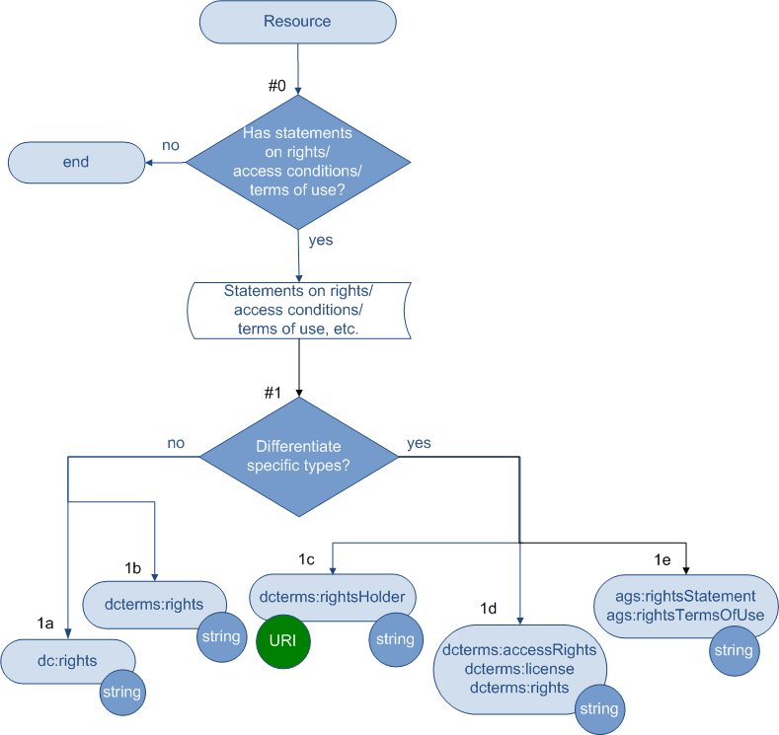

Note
- The property may be named as: rights or rights statement. More detailed types of statements may include access rights, terms of use, access condition/access rights, license.
- Examples of the values (strings or URIs) are from: http://dublincore.org/usage/meetings/2004/03/dc-rights-proposal.html

Decision | Question | Answer | Action | Value Type | Examples
 |  |  |  |  | Metadata Term | Value
#0 | Use any controlled vocabulary ? | No | End
#0 | Use any controlled vocabulary ? | Yes | Continue to #1
#1 | Differentiate specific types or parts in the rights statement? | No | 1a | string | dc:rights | Copyright 1996-2007 XYZ Productions. All rights reserved.
 |  |  |  |  |  | http://www.fao.org/corp/copyright/en/
#1 |  | No | 1b | string | dcterms:rights | Copyright 1996-2007 XYZ Productions. All rights reserved.
 |  |  |  |  |  | http://www.fao.org/corp/copyright/en/
#1 |  | Yes | 1c | string or URI | dcterms:rightsHolder | XYZ Productions
 |  |  |  |  |  | http://www.fao.org/
#1 |  | Yes | 1d | string | dcterms:accessRights | http://www.fao.org/corp/copyright/en/
 |  |  |  |  |  | Available to subscribers only.
 |  |  |  |  | dcterms:license | http://creativecommons.org/licenses/by/3.0/
 |  |  |  |  |  | Licensed for use under Creative Commons Attribution 3.0
 |  |  |  |  |  | http://www.fao.org/teca/content/disclaimer-1
 |  |  |  |  | dcterms:rights | [any other type of statements]
#1 |  | Yes | 1e | string | ags:rightsStatement | Copyright 1996-2007 XYZ Productions. All rights reserved.
 |  |  |  |  |  | http://www.fao.org/corp/copyright/en/
 |  |  |  |  | ags:termsOfUse | Access limited to members.

8. Usage

Relation with a resource being described: Resource has usage information.

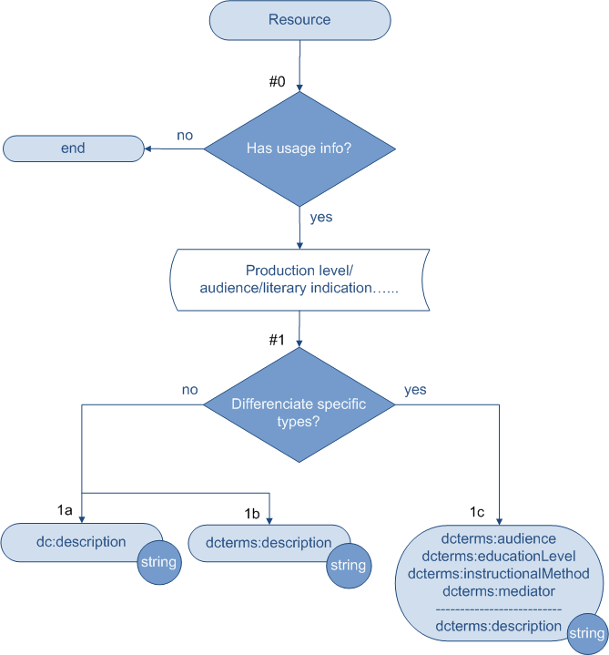

Note
- In presenting the usage-related information, different words might be used in your situation, for example, “Production Level”, “Audience”, “Literary Indication”, etc.
- Values for this property that are text strings are considered in this document. It is also possible that the values are controlled by a vocabulary or dataset which is available as Linked Data. For such a situation, consult “6.2. Type/Genre” for options.

Decision | Question | Answer | Action | Value Type | Examples
 |  |  |  |  | Metadata Term | Value
#0 | Has usage info? | No | End
#0 | Has usage info? | Yes | Continue to #1
#1 | Differentiate specific types of usage data?  (e.g., Production level/Audience/Literary indication, etc.) | No | 1a | String | dc:description | audience: Public[1]
#1 |  | No | 1b | String | dcterms:description | audience: Public[1]
#1 |  | Yes | 1c | String | dcterms:audience | Public [1]
 |  |  |  |  | dcterms:educationLevel | UK Educational Level 1 [2]
 |  |  |  |  | dcterms:instructionalMethod | Direct Teaching [3]
 |  |  |  |  | dcterms:mediator | Reading specialist [4]
 |  |  |  |  | dcterms:description | [any other usage data]

[1] Example taken from ProdINRA sample record.
[2] Example taken from UK Educational Levels (UKEL) list: http://www.ukoln.ac.uk/metadata/education/ukel/
[3] Example taken from ADPRIMA Instructional Methods Information list of Instructional Methods:http://www.adprima.com/teachmeth.htm
[4] Example taken from Diane Hillmann (2005) Using Dublin Core. http://dublincore.org/documents/usageguide/

[9. Relation]

9.1 Relation between resources

Relation being described: The resource is related to another resource.

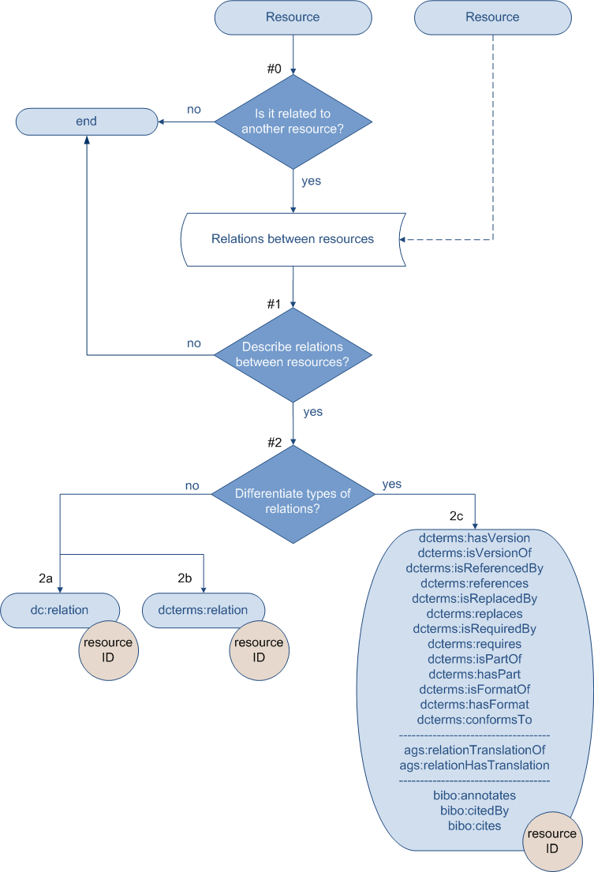

Note
- When a resource is related to another resource, a decision should be made regarding whether the relations between the two resources need to be described.
- In describing the relations, a great number of relation types can be used. The available metadata terms listed below do not form an exhaustive list. Other types may exist.
- The involved resources should always be represented by their identifiers. Values for this property are always the identifiers.

Decision | Question | Answer | Action | Value Type | Examples
 |  |  |  |  | Metadata Term | Value
#0 | Is it related to another resource? | No | End
#0 | Is it related to another resource? | Yes | Continue to #1
#1 | Describe relations between resources? | No | End
#1 | Describe relations between resources? | Yes | Continue to #2
#2 | Differentiate types of relation? | No | 2a | ID | dc:relation | 12345
#2 | Differentiate types of relation? | No | 2b | ID | dcterms:relation | 12345
#2 | Differentiate types of relation? | Yes | 2c | ID | dcterms:isVersionOf  dcterms:hasVersion  dcterms:isReplacedBy  dcterms:replaces  dcterms:isRequiredBy  dcterms:requires  dcterms:isPartOf  dcterms:hasPart  dcterms:isReferencedBy  dcterms:references  ags:relationTranslationOf  bibo:annotates  bibo:citedBy  bibo:cites | 12345

9.2 Relation between agents
Relation being described: The agent is related to another agent, specifically affiliation and funding.

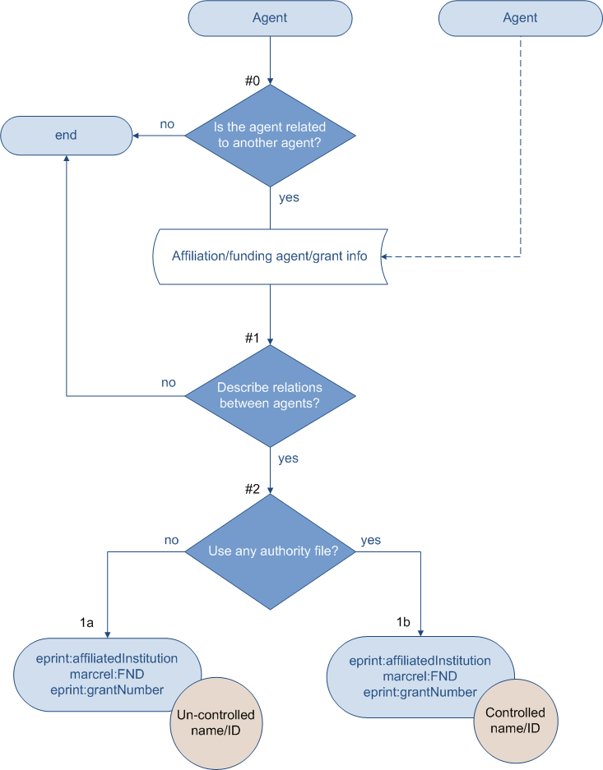

Note
- When an agent is related to another agent, a decision needs to be made regarding whether the relations between the two agents should be described.
- There could be various types of relations between agents. The available metadata terms listed below focus on the affiliation and funding information and do not form an exhaustive list. Consult MARC List for Relators (marcrel) http://id.loc.gov/vocabulary/relators.html for more types of relators.
- It is highly recommended that agents always be represented by their identifiers or controlled names.

Decision | Question | Answer | Action | Value Type | Examples
 |  |  |  |  | Metadata Term | Value
#0 | Is the agent related to another agent? | No | End
#0 | Is the agent related to another agent? | Yes | Continue to #1
#1 | Describe relations between agents? | No | End
#1 | Describe relations between agents? | Yes | Continue to #2
#2 | Do you use any authority file for the names of the agents? | No | 1a | Un-controlled name/ID | eprint:affiliatedInstitution | Univ Bristol
 |  |  |  |  | marcrel:FND [1] | The Mellon Foundation
 |  |  |  |  | eprint:grantNumber | A456X
#2 | Do you use any authority file for the names of the agents? | Yes | 1b | Controlled name/ID | eprint:affiliatedInstitution | University of Bristol
 |  |  |  |  | eprint:grantNumber | A456X
 |  |  |  |  | marcrel:FND [1] | The Andrew W. Mellon Foundation

[1] marcrel:FND represent “Funder” and has an URI: http://id.loc.gov/vocabulary/relators/fnd.html.
-- From the MARC List for Relators: http://id.loc.gov/vocabulary/relators/fnd.html

Appendixes

Appendix A. Explanation of Terminology

“Metadata Terms” and “Properties”
“[metadata] elements”, “[metadata] fields”, and “attributes [of an entity]” have been widely used by the professionals who are involved in creating, designing, and implementing metadata standards. In a number of metadata structure standards it is the term “elements” that have dominated in the specifications. Some standards (e.g., those used by library, museum, and archives communities) prepared their data structure standards (e.g., MODS, CDWA, VRA Core, EAD) using XML schema as the primary medium. These specifications modelled the structure with “elements”, related “attributes”, and controlled “attribute values” throughout the element sets. Nevertheless, as represented by DCTERMS, the RDF terminology instead of the XML terminology is now gaining momentum. The term “properties” of resources are used in place of “elements” in the LOD report.

This document considers the process of metadata description as the description of properties of a resource. For example, ‘rights’ is considered as a property of a resource.
Property: rights
Because there are various levels of granularity and multiple corresponding ways this property can be described, LODE-BD uses “metadata term” for a specific element provided by a metadata element set. For example, property ‘rights’ can be described by metadata terms from different namespaces:
Metadata term: dc:rights
Metadata term: dcterms:rights
Metadata term: ags:rightsStatement

“String” and “URI” as values
In this document, the words ‘string’ and ‘URI’ are used for the most commonly seen values in bibliographic data. They correspond to the terminology of RDF in the form of ‘literal’ (typically a string of characters) and ‘non-literal’.

“literal
The most primitive value type represented in RDF, typically a string of characters. The content of a literal is not interpreted by RDF itself and may contain additional XML markup. Literals are distinguished from Resources in that the RDF model does not permit literals to be the subject of a statement.”

“A plain literal is a string combined with an optional language tag. This may be used for plain text in a natural language. As recommended in the RDF formal semantics [RDF-SEMANTICS], these plain literals are self-denoting.”

“A literal is an entity which uses a Unicode string as a lexical form, together with an optional language tag or datatype, to denote a resource.”

“non-literal value
A value which is a physical, digital or conceptual entity.”

For example, “rice” is a concept included in the AGROVOC Thesaurus, with a preferred label (in English), “Rice.” When the thesaurus is published as Linked Data, the concept is considered as a resource and is given a unique URI, http://aims.fao.org/aos/agrovoc/c_6599. This means that a URI reference is used to identify this concept as a resource.

In this situation for the property: subject, the metadata terms for encoding this property include dc:subject and dcterms:subject. Because dcterms:subject “is intended to be used with non-literal values as defined in the DCMI Abstract Model (http://dublincore.org/documents/abstract-model/)”, the value to be used associated with this metadata term should be the URI http://aims.fao.org/aos/agrovoc/c_6599 which represents the concept as a resource instead of “Rice” or other language labels which represent the concept.

Based on the definition of these metadata terms, the following examples are provided:

dc:subject Rice
dcterms:subject http://aims.fao.org/aos/agrovoc/c_6599

“URI” as a value recommend in this document represents “http URI” only.

“Resource”
The term “Resource” is used in the conceptual model to denote a general entity, the Bibliographic Resource. An instance of the bibliographic resource can be an article, monograph, thesis, conference paper, research report, etc., regardless if it is in print or electronic format. The range of the ‘Resource’ is consistent with what the Dublin Core referred to as ‘resource description’. However, it is narrower than rdf:Resource where Resource is an entity of anything in the universe, or is a name of the class of everything.

“resource
An abstract object that represents either a physical object such as a person or a book or a conceptual object such as a color or the class of things that have colors. Web pages are usually considered to be physical objects, but the distinction between physical and conceptual or abstract objects is not important to RDF. A resource can also be a component of a larger object; for example, a resource can represent a specific person's left hand or a specific paragraph out of a document.”

In the flowcharts provided by the LODE-BD Recommendations, the ‘resource’ at the beginning oval box is an instance of the bibliographic resource.

Appendix B. References

How to publish and consume Linked Data

Linked Data: Evolving the Web into a Global Data Space (1st edition), Tom Heath and Christian Bizer (2011). Synthesis Lectures on the Semantic Web: Theory and Technology, 1:1, 1-136. Morgan & Claypool.
URL: http://linkeddatabook.com

"This book gives an overview of the principles of Linked Data as well as the Web of Data that has emerged through the application of these principles. The book discusses patterns for publishing Linked Data, describes deployed Linked Data applications and examines their architecture."

Linked Data Patterns, Leigh Dodds and Ian Davis.
URL: http://patterns.dataincubator.org/book/

"A pattern catalogue for modelling, publishing, and consuming Linked Data."

Linked Data Tutorial NG - Publishing and Consuming Linked Data with RDFa, Michael Hausenblas and Richard Cyganiak.
URL: http://ld2sd.deri.org/lod-ng-tutorial/

"This note describes, step-by-step, how to create and consume linked data with RDFa."

Linked Data star scheme by example
URL: http://lab.linkeddata.deri.ie/2010/star-scheme-by-example/

"Tim Berners-Lee suggested a 5-star deployment scheme for Linked Open Data and Ed Summers provided a nice rendering of it."

Linked Data - Design Issues, Tim Berners-Lee (2006).
URL: http://www.w3.org/DesignIssues/LinkedData.html

One of the first discussions of the topic, mentioning the "four rules of Linked Data".

Cool URIs for the Semantic Web. Leo Sauermann and Richard Cyganiak (2008). W3C Interest Group Note.
URL: http://www.w3.org/TR/cooluris/

Where to find Linked Data sets

Linked Open Data Cloud - Datasets in the Linking Open Data Cloud diagram.
URL: http://ckan.net/group/lodcloud

The Linking Open Data cloud diagram.
URL: http://richard.cyganiak.de/2007/10/lod/

Syntax guidelines

DC-TEXT [DCMI Recommendation]. "Expressing Dublin Core metadata using the DC-Text format"
URL: http://www.dublincore.org/documents/dc-text/
Its primary use is in presenting metadata constructs for human consumption.
DC-HTML [DCMI Recommendation]. "Expressing Dublin Core metadata using HTML/XHTML meta and link elements"
URL: http://www.dublincore.org/documents/dc-html/
It describes how a Dublin Core metadata description set can be encoded using the HTML/XHTML <meta> and <link> elements. This specification is also an HTML "meta data profile" as defined by the HTML specification.
DC-DS-XML [DCMI Recommendation]. "Expressing Dublin Core Description Sets using XML (DC-DS-XML)"
URL: http://www.dublincore.org/documents/dc-ds-xml/
It specifies an XML format for representing a Dublin Core metadata description set.
DC-RDF [DCMI Recommendation]. "Expressing Dublin Core metadata using the Resource Description Framework (RDF)"
http://www.dublincore.org/documents/dc-rdf/
It describes how constructs of the DCMI Abstract Model may be expressed in RDF graphs.

VOA3R http://voa3r.eu/
Resource Description Framework (RDF) Model and Syntax Specification (1999-02-22). Glossary for this source http://www.w3.org/2003/glossary/keyword/All/literal.html?keywords=literal Last accessed February 2011
Resource Description Framework (RDF): Concepts and Abstract Syntax. http://www.w3.org/TR/rdf-concepts/#section-Literals Last accessed February 2011
DCMI Abstract Model. http://www.dublincore.org/documents/abstract-model/ Last accessed February 2011
Ibid.
DC Terms. http://dublincore.org/documents/dcmi-terms/#terms-subject Last accessed February 2011
From Resource Description Framework (RDF) Model and Syntax Specification (1999-2-22). Glossary for this source http://www.w3.org/2003/glossary/keyword/All/resource.html?keywords=resource Last accessed February 2011
Section prepared by Hannes Ebner < http://electricbum.wordpress.com/ >

